LFU Cache
Problem Statement: Design and implement a data structure for a Least Frequently Used (LFU) cache.
Implement the LFUCache class with the following functions:
LFUCache(int capacity): Initialize the object with the specified capacity.
int get(int key): Retrieve the value of the key if it exists in the cache; otherwise, return -1.
void put(int key, int value): Update the value of the key if it is present in the cache, or insert the key if it is not already present. If the cache has reached its capacity, invalidate and remove the least frequently used key before inserting a new item. In case of a tie (i.e., two or more keys with the same frequency), invalidate the least recently used key.
A use counter is maintained for each key in the cache to determine the least frequently used key. The key with the smallest use counter is considered the least frequently used.
When a key is first inserted into the cache, its use counter is set to 1 due to the put operation. The use counter for a key in the cache is incremented whenever a get or put operation is called on it. Ensure that the functions get and put run in O(1) average time complexity.

Example 1:
Input: ["LFUCache", "put", "put", "get", "put", "get", "get", "put", "get", "get", "get"]
Output: [null, null, null, 1, null, -1, 3, null, -1, 3, 4]
Explanation:
LFUCache lfu = new LFUCache(2); Initializing cache with capacity of 2.
lfu.put(1, 1); Cache becomes: [1, _], cnt(1)=1.
lfu.put(2, 2); Cache becomes: [2, 1], cnt(2)=1, cnt(1)=1.
lfu.get(1); Returns 1. Cache becomes: [1, 2], cnt(2)=1, cnt(1)=2.
lfu.put(3, 3); Cache evicts 2 as it has the lowest frequency. Cache becomes: [3, 1], cnt(3)=1, cnt(1)=2.
lfu.get(2); Returns -1 (not found).
lfu.get(3); Returns 3. Cache becomes: [3, 1], cnt(3)=2, cnt(1)=2.
lfu.put(4, 4); Cache evicts 1 (LRU). Cache becomes: [4, 3], cnt(4)=1, cnt(3)=2.
lfu.get(1); Returns -1 (not found).
lfu.get(3); Returns 3. Cache becomes: [3, 4], cnt(4)=1, cnt(3)=3.
lfu.get(4); Returns 4. Cache becomes: [4, 3], cnt(4)=2, cnt(3)=3.

Algorithm
- Initialize the cache with a specified capacity
- Create dummy head and tail nodes for each frequency list to simplify edge case handling
- For updating frequency, when a node is accessed or updated:
  - Remove the node from its current frequency list
  - If this was the only node in the minimum frequency list, increment the minimum frequency
  - Increment the node's frequency and add it to the front of the list corresponding to the new frequency
  - Update both hash maps (keyNode and freqNode) to reflect the changes
- For the "get" operation, check if the key exists in the keyNode map:
  - If present, retrieve the node, update its frequency, and return its value
  - If not present, return -1
- For the "put" operation:
  - If the key already exists in keyNode, update its value, update its frequency, and return
  - If not present, check if the cache is at capacity
  - If at capacity, remove the least frequently used node (node with the minimum frequency and least recent usage)
  - Create a new node for the key-value pair, set its frequency to 1, and add it to the front of the frequency list for nodes with frequency 1
  - Update both hash maps to reflect the addition of the new node
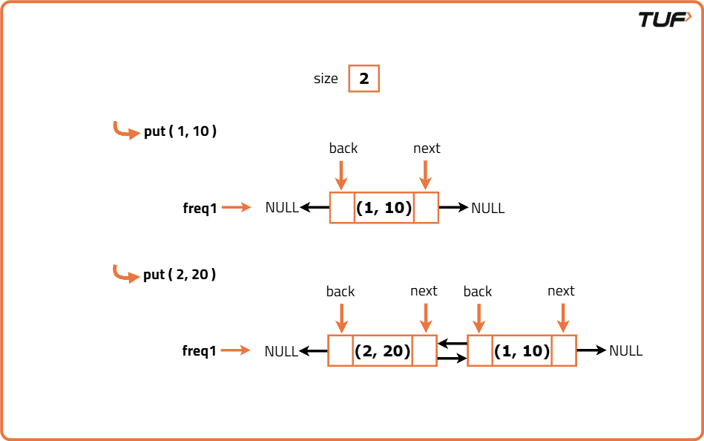
import java.util.HashMap;
import java.util.Map;

/* To implement a node in doubly linked list that will store data items */
class Node {
int key, value, cnt;
Node next;
Node prev;

Node(int _key, int _value) {
key = _key;
value = _value;
cnt = 1;
}
}

// To implement the doubly linked list
class List {
int size; // Size
Node head; // Dummy head
Node tail; // Dummy tail

// Constructor
List() {
head = new Node(0, 0);
tail = new Node(0, 0);
head.next = tail;
tail.prev = head;
size = 0;
}

// Function to add node in front
void addFront(Node node) {
Node temp = head.next;
node.next = temp;
node.prev = head;
head.next = node;
temp.prev = node;
size++;
}

// Function to remove node from the list
void removeNode(Node delnode) {
Node prevNode = delnode.prev;
Node nextNode = delnode.next;
prevNode.next = nextNode;
nextNode.prev = prevNode;
size--;
}
}

// Class to implement LFU cache
class LFUCache {
private Map<Integer, Node> keyNode; // Hashmap to store the key-nodes pairs
private Map<Integer, List> freqListMap; // Hashmap to maintain the lists with different frequencies
private int maxSizeCache; // Max size of cache
private int minFreq; // To store the frequency of least frequently used data-item
private int curSize; // To store current size of cache

// Constructor
public LFUCache(int capacity) {
maxSizeCache = capacity;
minFreq = 0;
curSize = 0;
keyNode = new HashMap<>();
freqListMap = new HashMap<>();
}
private void updateFreqListMap(Node node) {
// Remove from Hashmap
keyNode.remove(node.key);

// Update the frequency list hashmap
freqListMap.get(node.cnt).removeNode(node);

// If node was the last node having its frequency
if (node.cnt == minFreq && freqListMap.get(node.cnt).size == 0) {
// Update the minimum frequency
minFreq++;
}

// Creating a dummy list for next higher frequency
List nextHigherFreqList = new List();

// If the next higher frequency list already exists
if (freqListMap.containsKey(node.cnt + 1)) {
// Update pointer to already existing list
nextHigherFreqList = freqListMap.get(node.cnt + 1);
}

// Increment the count of data-item
node.cnt += 1;

// Add the node in front of higher frequency list
nextHigherFreqList.addFront(node);

// Update the frequency list map
freqListMap.put(node.cnt, nextHigherFreqList);
keyNode.put(node.key, node);
}

// Method to get the value of key from LFU cache
public int get(int key) {
// Return the value if key exists
if (keyNode.containsKey(key)) {
Node node = keyNode.get(key); // Get the node
int val = node.value; // Get the value
updateFreqListMap(node); // Update the frequency
// Return the value
return val;
}
// Return -1 if key is not found
return -1;
}

// Method to insert key-value pair in LFU cache
public void put(int key, int value) {
/* If the size of Cache is 0,
no data-items can be inserted */
if (maxSizeCache == 0) {
return;
}

// If key already exists
if (keyNode.containsKey(key)) {
// Get the node
Node node = keyNode.get(key);
// Update the value
node.value = value;
// Update the frequency
updateFreqListMap(node);
} else {
// If cache limit is reached
if (curSize == maxSizeCache) {
// Remove the least frequently used data-item
List list = freqListMap.get(minFreq);
keyNode.remove(list.tail.prev.key);

// Update the frequency map
freqListMap.get(minFreq).removeNode(list.tail.prev);
// Decrement the current size of cache
curSize--;
}
// Increment the current cache size
curSize++;

// Adding new value to the cache
minFreq = 1; // Set its frequency to 1

// Create a dummy list
List listFreq = new List();

// If the list already exists
if (freqListMap.containsKey(minFreq)) {
// Update the pointer to already present list
listFreq = freqListMap.get(minFreq);
}

// Create the node to store data-item
Node node = new Node(key, value);

// Add the node to dummy list
listFreq.addFront(node);

// Add the node to Hashmap
keyNode.put(key, node);

// Update the frequency list map
freqListMap.put(minFreq, listFreq);
}
}
}
Time Complexity: O(N), where N is the number of queries on the LFU cache. Each get and put method takes an average of constant time, making the overall complexity O(N).
Space Complexity: O(cap), where cap is the capacity of the LFU cache. The cache can store a maximum of cap data items, taking O(cap) space.

